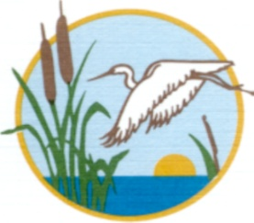
MELBOURNE-TILLMAN WATER CONTROL DISTRICT
AGENDA

The Regular Meeting of the Board of Directors of the Melbourne-Tillman Water Control District (MTWCD) will be held on Tuesday, December 2, 2025 at 9:00 AM in the Council Chambers of the City of West Melbourne, 2285 Minton Road, West Melbourne, Florida.

- INTRODUCTION
- Call to Order
- Pledge of Allegiance
- Roll Call
- Recognition of Guest/Visitors/Staff
- Announcements

- PUBLIC COMMENTS

- PRESENTATIONS

- REGULAR BUSINESS
  - Approval of Minutes, October 28, 2025 Board Meeting
  - Operating Statement through October 31, 2025

- NEW BUSINESS
  - Annual Review of Corcoran Partners Contract for Services
  - Modifications to MTWCD Policy P232, Leave

- OLD BUSINESS
  - None
- BUDGET
  - None

- STAFF REPORTS
- Manager’s Report
- Engineer’s Report
- Assistant Manager/Operations Report
- Attorney’s Report
- Secretary/Treasurer’s Report

- CLOSING
- Meeting Schedule
- Board Member Reports
- Adjourn
Pursuant to Section 286-0105,FSS, if an individual decides to appeal any decision made by the Melbourne-Tillman Water Control District Board of Directors with respect to any matter considered at this meeting, a verbatim transcript of the proceedings may be required and the individual will need to ensure that a verbatim transcript of the proceedings is made,
In accordance with the Americans with Disabilities Act and Section 286.26, FSS, persons needing special accommodations for this meeting shall within reasonable time, prior to this meeting, contact the Office of the Secretary to the Board of Directors, (321)-723-7233.

